**Experiment No. 5**

Aim: To set up multiple IP addresses on a single LAN and using netstat and route commands viewing current routing table.

Requirement: Windows/Linux/MAC OS in PC/Laptop, compatible version of terminal in OS.

Theory:

The concept of creating or configuring multiple IP addresses on a single network interface is called IP aliasing. IP aliasing is very useful for setting up multiple virtual sites on Apache using one single network interface with different IP addresses on a single subnet network.

The main advantage of using this IP aliasing is, you don’t need to have a physical adapter attached to each IP, but instead you can create multiple or many virtual interfaces (aliases) to a single physical card.

Below we create virtual interface and assign multiple IP Address in Kali Linux:

1) Before ipaliasing:

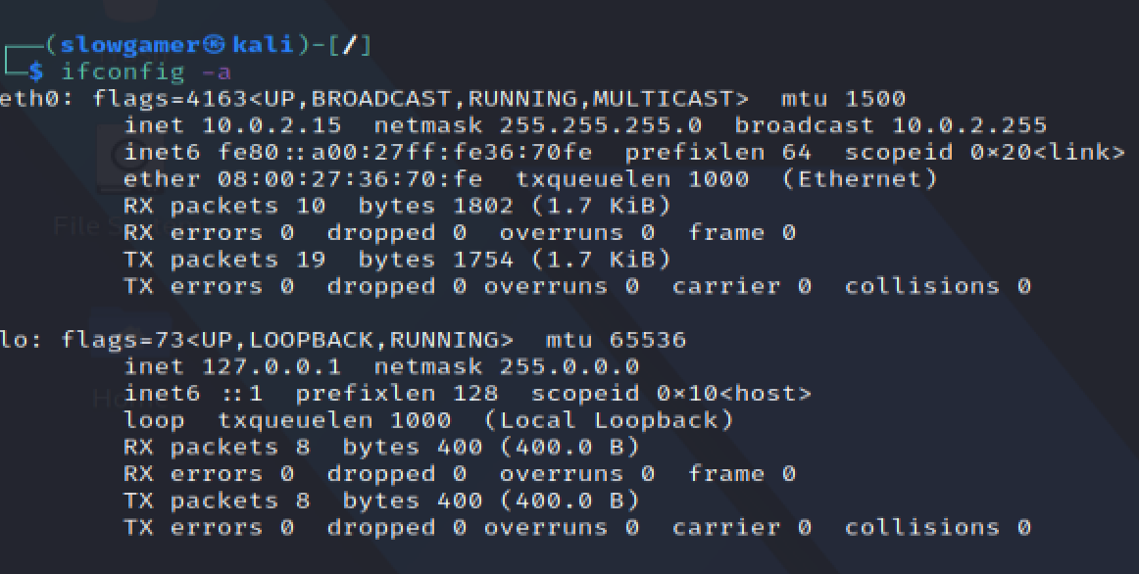

2) After ipaliasing:

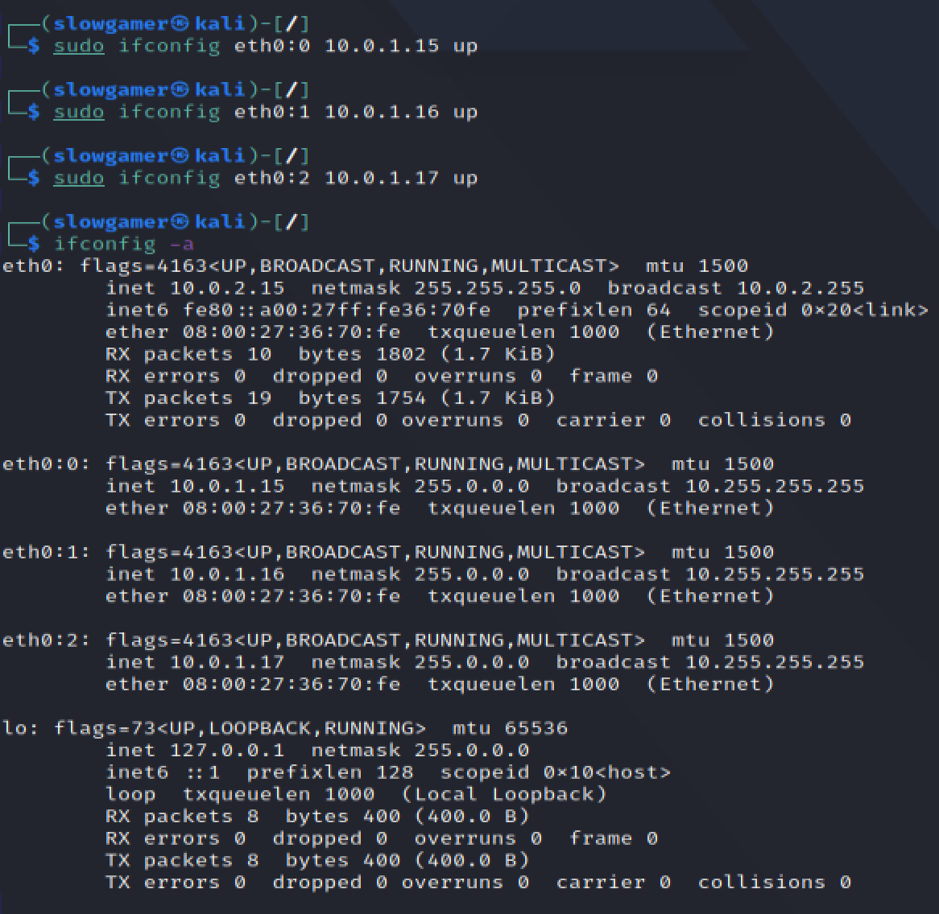

3) Netstat and route command:

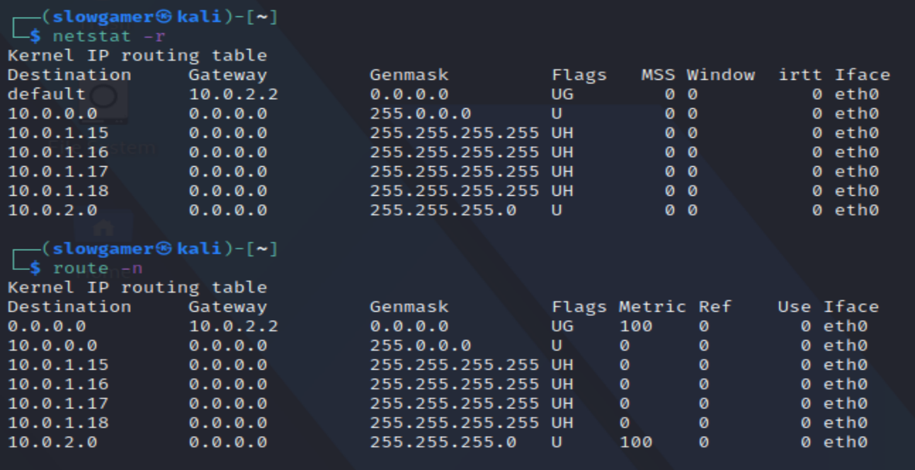

Conclusion: We have successfully added Multiple IP addresses to single NIC in Kali Linux OS and using netstat and route command we have displayed routing table.